Thoughts on Kenya – From the mind of Liam Stockwell
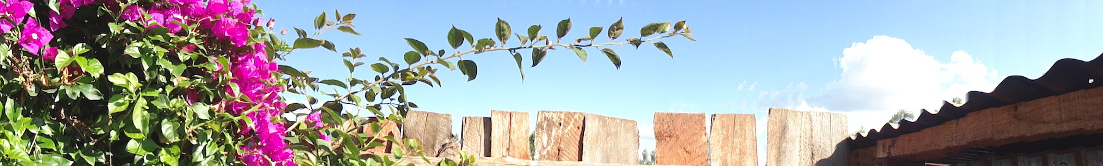
The river runs deep where it doesn’t run wide.
Day one.
The last day of fall semester 2010. Ten hours of our lives lost to traveling quickly east. Crammed in a beetle. A 777 and the last row of the plane from Heathrow to Nairobi before a darkened bus ride over the bouncy roads before meeting Emmanuels sister-in-law and niece. Animals innards stuffed into dough and deep-fried. Sweetish little homemade doughnuts still warm from the oil and a spot of hot Kenyan tea. (Warmed further with a splashing of vodka acquired from the duty free, the gentleman behind the counter informing me that I was not to claim the bottle and if it was asked about, to tell them I purchased it prior to my landing here.)
We have gracefully swung into the first morning in Nairobi, Kenya. Emmanuel had promised me ‘no rain’. Promised. And as I put down these words the rain has once again picked up outside. The birds have once again hushed as the gutter run-off turns from a leaky faucet to a tumult of splashes and gurgles. Though judging from the pine needles sticking over the edge of the gutter and the small plants sprouting from within, I’m not sure if most of what is falling upon the roof is actually reaching the ground. The flora seems to be taking its fair share, judging from the healthy shape it finds itself in.
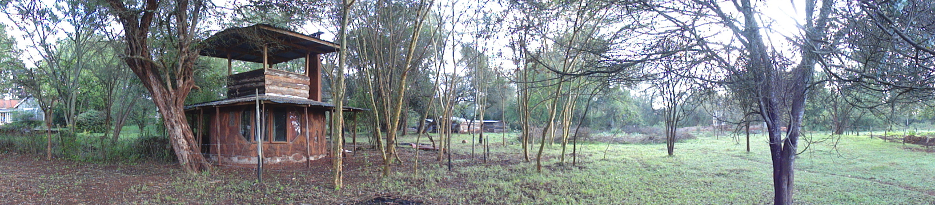
Eshel Gardens is a garden indeed. The rain forest seems relentless. All that I had pictured in my head of arid landscapes, dry-land farms with scrub trees and red dirt roads, is naught. The lushness of the climate is but forcing itself upon you. Flowers tint the early morning bedroom walls with subtly lighted washes of red and purple prying ones eyes awake to my first day spent in the southern hemisphere. Branches encroach the roof and trails alike. The ground is indeed red earth trails but it seems that they must sternly hold their own against the onslaught of grass and vegetation. Though one must admit the stark contrast is visually stunning. The red and green having a strange harkening to the Christmas season that is so rapidly approaching. (Forcing itself onto the radio airwaves and onto the store shelves. The snowy, pine tree, north pole, Coca-Cola® santa seems to persist even here in Kenya, sadly.) In these warm humid climes one feels so removed from the chill winds of Wyoming and anything that santa could possibly land his sleigh upon.
Kenyan time.
We all seem to be up and about rather early seeing as we had spent the previous day, in full, traveling nearly halfway around the globe. This strange occurrence can probably be chalked up to the fact that we are, in fact, halfway around the globe, equally as far from our homes, for some of us this is our first time out of the country of our births, the sun rises early in these parts, and the fact that we are horribly excited. Waking in the hours of half light to take cold showers or slow walks in the drizzle drifting down slowly outside. Breakfast seems a rather extensive affair with chai teas, fresh fruit and fruit juices, and the whole spread. Breakfast also acting as a great catalyst to start the slow process of rousing the slow-risers, the long bathers, and the careful dressers. As the holiday continues it prove to be, not an easier, but rather more harsh and complicated task to get everybody together and out the door in an orderly, timely fashion. This will be referred to as ‘Kenyan time’ as group dynamics grow and improve, and will show itself to be a continued problem in some of the group members eyes. Though I think most of us found ourselves truly enjoying the relaxed atmosphere ‘Kenyan time’ can instill within the group when all members are resolved with the simple principles it employs; a complete disregard for even caring what time it could be at any given moment, the idea that everybody else that one could possibly be in a hurry to interact with is probably using ‘Kenyan time’ as well, and a strong disposition to be deeply distracted at any given moment. And by the end of the trip I think most members were well adjusted to any sort of time zone we may have passed into. Rather physical, metaphorical, or of the Twilight type. Either way, this will become a running joke throughout the trip. Mainly aimed towards Emmanuel and his having planted the fast growing seed of slow ‘Kenyan time’ within our ranks. (And perhaps for the fact that he is surely a supreme executor of these principles.)
Some time spent at a rather large and newly built shopping center (Indeed this will be loving referred to as Wal-mart for the remainder of the trip.) in order to use ATM machines and stock up on the basic necessities of the holiday lifestyle. Namely snacks for the long bus rides looming in or very near future, chocolate, and any-and-all types of alcoholic beverages to be used as aperitifs, friend creators, nerve un-winders, and night caps. Lunch at an upstairs bistro in the French fashion and one of the best baguettes I have enjoyed since the outdoor cafes of Paris. An extremely large banner picturing the snow-topped Matterhorn trying to distill a sense of holiday resort ease just fifteen stairs off the hot, dusty, busy Kenyan street.
Too much money and a few ego crushing bargaining transactions later and we drag our selves out of a street market. Happily sharing stories and peaks at our newly found trinkets and gifts.
We seem as though we shall be the sort of group that should be able to get along in a reasonably smooth fashion. Not too much of the griping or rabble rousing of others nerves that can often become a problem among groups of our size. (We are nineteen all said and done. Though Mike and Erin have been delayed through various changes of weather, wind conditions, flight changing restrictions and the like.) We all gather for large buffet style dinners and sit in no particular order or divide ourselves into no particular groups. If something needs to be gone over for any specific reason it is brought to the table for discussion, vote or the simple point of letting everybody know the case. Over these meals and discussion sessions; the day is gone over, knowledge is re-hashed, re-taught, and questioned, plans are set and times arranged. The faire is of what I take to be traditional Kenyan array. A strong randomly cut of meat, mamosa (cornmeal hash of a sort, normally bianco maize) traditionally used as a eating utensil, a bean or rice as a carbohydrate, and fruit. Fresh fruit! Watermelon, mango, bananas, plantains, and melons of many types. Good eating at it’s best!
Due.
Day two (or three, depending on how the time zones have switched, whether you count our day-long travel session, and how quickly one adjusts to Kenyan time) and the tours begin. I am at first surprised to find that we have pulled of the pavement and up to a large, heavily guarded gate. The entrance to a prison. We shall be touring the minimum security boys rehabilitation center. Which sets directly next to the men’s medium and maximum security facilities. Not so subtly saying, ‘Keep your nose clean or this is what you can look forward to in the future’. Though the sign on the front gate spoke of Kurekebisha na Haki (adjust the right) or as I was told, loosely translates to ‘Justice Through Pride’. With a modest yet, I’m sure, difficult to achieve mission statement, ‘To contain youthful offenders in safe, human conditions in order to facilitate responsive administration of justice, rehabilitation, social re-integration and community protection’. Justice Through Pride. The facility consisted of housing for roughly forty-five boys from the ages of fourteen to eighteen, classrooms, workshop spaces and a small farm. This would be our first viewing of what we would soon be shone any number of times throughout the other tours we would take in the remaining days of our trip. What we would come to know as bio-intensive agriculture, or B.I.A. (insert BIA write-up here) The implementation of organic matter recycling, water conservation, small farmyard animal cultivation, and crop rotation taught to us by these boys, themselves. Worms in the compost, goats, rabbits and chinchillas in their cages, plants in the soil in rows, all led to a clean, orderly feel to their small-scale agricultural program. I’m sure helping these young boys under stand the importance of structure and organizational skills in life. After our brief tour of the farm, fruit trees and vertical growth towers, we headed into the classroom for an introduction and demonstration of what some of the other boys on the premise learned with their time institutionalized. They had a number of different programs they could be enrolled in in-order to receive knowledge about certain tasks that could, and hopefully would, help them become productive members of their communities. These included the making of soaps, bleach, yogurt, juice, and the drying of seeds for planting. Now, these boys could be locked-up for any number of reasons. We were told, ‘From serious crimes to haven stolen a pineapple’. So, even though these are probably practical skills for the real world where opportunities could be hard to come-by for these boys, I couldn’t help but notice that perhaps they were being taught rather simple, narrow trades. It seemed that many of them were not doing much more than mixing ingredients. I’m afraid they may have been missing the business and salesmanship aspects necessary for carrying these skills over into the future. But all-in-all I was happy to see the positive effects this experience was having on these boys. And I imagine our penile system could learn a thing or two from this outfit. The classroom in which this brief meeting of cultures took place was adorned with pictures the boys had drawn. Seeing as the boys were only kept for three-month training periods, I’m not sure if these pictures belonged to these boys in particular, but there was a bright blue and yellow ‘OBAMA’ placard and one that simply and strongly stated, ‘Kenya is my Country’.
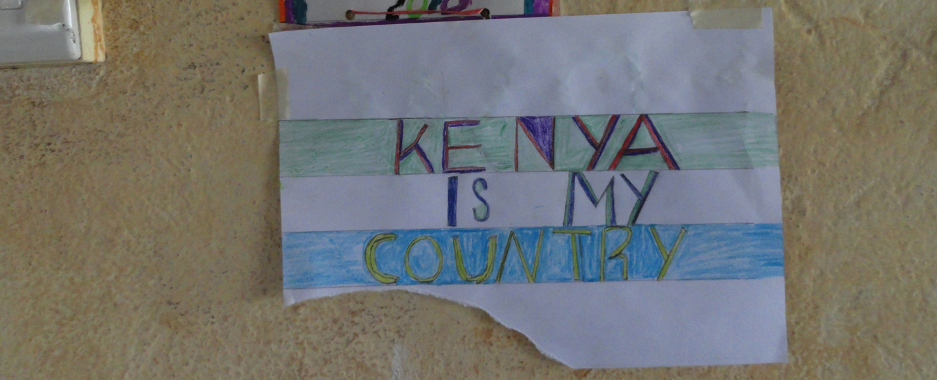

Day…three-ish?
Toilets (Cloak Room : in ancient English.) in Kenya work on some sort of strange bladder-pumping sort of system that never really seems to work for what it was actually designed for at some point in time, which is, I’m sure, flushing toilets. With the correct timing and pressure on the otherwise normal looking hand actuated flushing mechanism…one could feasible force the thing into actually removing refuse…or perhaps an extreme force of will…though it is more than likely the case that one must brush their teeth, wash ones face, or leave the room in order to come back and try to will the day old lunch out into the septic field. I actually found that if one is simply removing the liquid waste that it is a much easier to slide out into the dark night and relieve oneself upon the grass…which is often in much need of the nutrients anyway. Urea, ammonias, and the nitrogen cycle in action.
Stick Wheels.
I know that Kenya was an English colony and that cricket is a rather well established sport here but I didn’t realize how ingrained other sportific past times are. Young boys seemed to have a rather innate knack for the ancient sport of wheel rolling. (come to find out this is actually a game documented from antiquity originating in perhaps Africa) From bicycle tires to bicycle rims to the large heavier tires of cars, this game seems to have a stronghold upon the younger generations. Probably because the simplicity and the ability to play the game with minimal equipment, money, or space. Often times, especially with the tires of a larger breed, the game is played with the lack of a stick, just pushin the tire smoothly and strait down the path. Fun-ness indeed!
I grew up in a family of six children that often had a few more friends or cousins tacked on for good measure. When we were of the age prone to playing with Hot-wheel® cars we would build intricate trail and road systems in the gravel driveway. Intricate with bridges and buildings abound. Then, as we traveled down the dusty gravel road on the outskirts of Masai Mara National Park I noticed a group of boys who appeared to be of the same push car age I am speaking of…building what appeared stylized versions of a Masai village. Small sticks placed in a tight circle in order to hold in the cows they walked around with their hands. Rocks used to imitate houses. Nice to notice the similarities between cultures so completely different…and how children are always so much the same, full of wonder and youthful energy.
The Rithum of the Music.
Erica calling out Paul Simons’ ‘Homeless’. The amazing harmonies of the South African Zulu male choral group, Ladysmith Black Mambazo, singing, “Webaba silale maweni. Homeless, Homeless, moonlight sleeping on a midnight lake.” Femi Kuti and his fourteen piece band Positive Force. K’naan and his brilliantly painful brand of Somali hip-hop from Mogadishu. He sings, “ T.I.A…..Hooray! T.I.A….means This Is Africa. You don’t know how hot it is here, streets is tricky in these parts here, you don’t know how hard it is here…simmer down. T.I.A….Hooray!” Paul Simons’ ‘You can call me Al’ coming from his very rhythm and African based Graceland album. “A man walks down the street. It’s a street in a strange world. Maybe it’s the third world. Maybe it’s his first time around. He doesn’t speak the language. He holds no currency. He is a foreign man. He is surrounded by the sound, sound, of cattle in the market place scatterlings and orphanages. He looks around, around, he sees angels in the architecture spinning in infinity. He says, ‘Amen. Hallelujah!’”
Wildlife. Gazelles and Theodore Geisel.
Whilst upon safari we were lucky enough to have seen many strange, exotic, and favorable looking creatures of Africa. We saw four of what they call ‘the big five’ game animals. (Though I personally find this title gross. That they would all be grouped into a class of animals based on their ability to grow large and be the main target of the trophy hunting community is disgusting. But, the big five they are called and ‘hunting’ with ones camera is much less the grotesque image one has of the bullet and the gun.) So, the big five, the Lion, the African Elephant, the Rhinoceros, the Cape Buffalo, and the Leopard. The later being the one that managed to elude us for the entire trip. Explaining how it gained it’s standing among the five hardest trophy animals to hunt on foot. We saw birds of many different types, Hippoponumis, tortoise, lizards, deer, zebra and gazelle. And while all these animals are indeed beautiful and regal in their own respective fashions, I would like to focus on the gazelle for a moment.
Being one of the smaller and more plentiful four-legged mammals upon the savannah, (and there are indeed many four-legged mammals upon the savannah) it is easy to loose interest in such an unremarkable being. They simply pale in shear size and aw-inducing ability that many of the larger or more confrontational beats. (The Cape Buffalo for instsance. Which will stare you down with eyes as big as bowling balls before charging your vehicle in what we were assured, was not charge.) The gazelle keep a delicate eye trained upon you as they maintain their distance and graze quietly upon the lush vegetation. They are sure to not let one get to close and seem just as happy to be chased off to any other piece of greenery to munch upon. (This seems to be the main pastime of the gazelle, indeed. Munching upon the grass.) Their tales flit wildly at what appears to be nothing in general. Giving them the appearance of the happy little dog. Wild to see you but to nervous to actually come lick your hand or even meet your acquaintance. Their faces being much shorter and blunter than the deer gives them a childish, indeed very friendly, outward portrayal of themselves. With large doe-e eyes and a tongue that will flit out of the mouth and random times and ears turning this way and that in constant search of the next possible encroaching threat they give the appearance of an animal that would enjoy the company of other warm blooded creatures but if to skittish to stand around the fire. Simply put, they are adorable. Soft fur of muted tans and white. Faces that illicit the deepest feelings of sympathy and friendliness. It is a wonder that anything could find the heart to eat them. Though this is the brutal reality of nature.
Theodore Geisel (a.k.a. Dr. Seuss used different horns, antlers, feathers and furs to make some of his better-known and indeed most impressive work outside of his well-known children’s stories. These were creations true to the seemingly off-handed mind of one of the worlds greatest creator of creatures. One of my personal favorites being the ‘Blue Green Abelard Sculpture’. And while it doesn’t look anything like a gazelle, really, it elicits feelings of friendship and the soft gentle frame of mind one might associate with a young child. Not that I would care to put one of their heads on my wall, but the Abelard and the Gazelle are beautiful creatures.
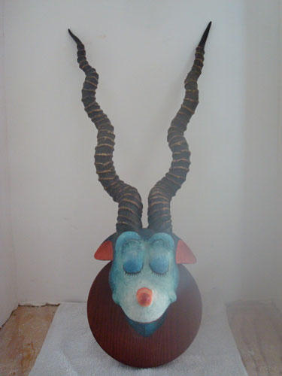
Tourism Tracks.
There also seems to be, if not great at the moment, the great threat of the effects dealt upon the land by the intrusion of tourism. With the peoples, the sight seekers, the photo hunters, the Audubon’s, the money they bring and the reach of the outside world, comes a great trampling of the landscape. As much as I wanted to get out of the four-wheel drive van and explore the savannah on foot. To get out and move silently under my own power. To reach beyond the hills blown upon nothing but the breeze and the scent of fresh soil and warm dung. To do such would most assuredly be a death sentence for the likes of me. I would be but a easily caught snack for the first lion I stumbled upon. Maybe a hastily taken picture or two documenting my own demise. For this simple fact, one must remain in the safety of a vehicle. And though this is surely the safest and easiest way in which to view the land and it’s natural inhabitants it has begun to show great damage done to the nature. I’m not sure how long guided truck tours have been happening in this region of Kenya, but the results of such are immense. They start small as a two track where it crosses the tongue of a river or soft lowland. Yet, before long these preliminary marks erode with consequential further use and the simple unavoidable aspects of nature. The rains bring dirtier rivers with excess erosion and the loss of valuable fauna along the riverbanks and bottoms. Granted, this is not the only place this sort of damage is caused by further encroachment of human activity. (Indeed everywhere humans do tread we seem to make our presence abundantly clear.) But in these far reaches of this vast land it is sad to see such definite proof of our inclusion in these lands. And for the sake of the native human and natural inhabitants both, I hope for this to be a serious consideration in the conservation of these beautiful regions.
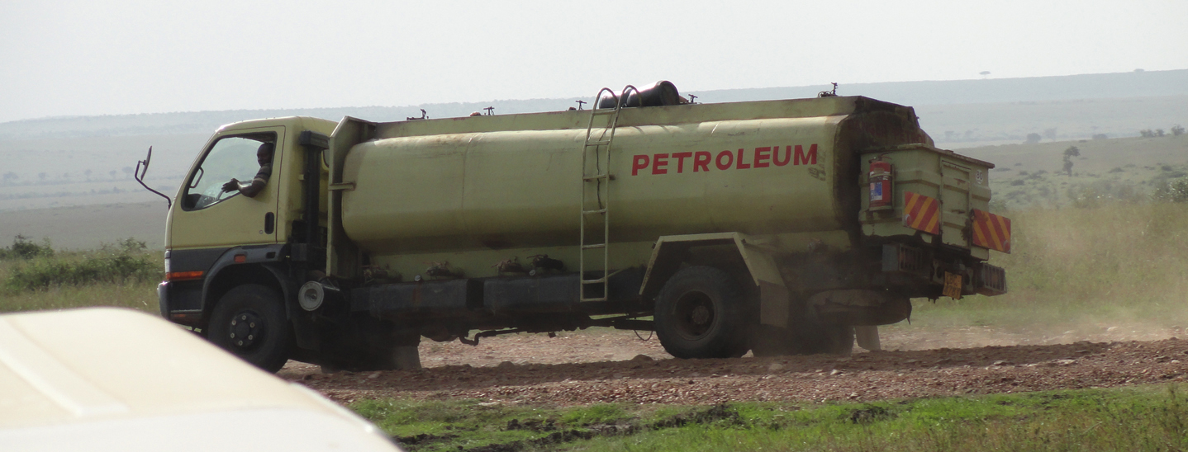
Something I would briefly brush upon, since we find ourselves so close to the topic, is the preservation of these lands and their interaction with the native Masai. With their traditional actions of having to kill a Lion as a right of passage into manhood their has apparently been a noticeable decrees in the population. And though this could certainly be a form of needed population control regarding safe levels of human-lion interactions, the fact that many more get killed during practices of cattle ranching and resource management. The same problems noticed nearly everywhere in the world that humans and large carnivorous animals overlap in interaction.

The Pink and the Blue. Colours of the Sexes. Crown® Zain®
Kenya being a beautiful country. Beautiful people, beautiful land, beautiful climate, beautiful culture, and flora and fauna. The need to express this beauty was abundantly clear in the street art of the country. From Swahili tags I couldn’t understand to pictures of Barack Obama (Who’s father is Kenyan) and past leaders of Kenya such as Kenyatta. (The first President of Kenya, from 1964 to 1978. Considered by many to be the father of the Kenyan Nation.) The will to express oneself is nearly always prevalent in any culture. I saw much paint used in the advertising of paint companies, namely Crown and Zain. Though I am sure that much of this had to do with the situation in which the owner of the fence probably got the paint for cheap or free in exchange for the large company logo that gets branded upon the brightly painted surface when complete. (And the colors were nearly always of a bright, nearly day-glow nature. Blue and pink seemed to be the favorites…perhaps these where the recognized colors of the respective paint manufactures?) Yet, I would love to see the articles of an artist become more accessible to the masses. With more stucco and brick walls than one could care to try and shake a stick at, it would be a truly fantastic cultural experiment to see what would evolve with the implementation of nearly 40million Kenyans’ creativity and paintbrushes!
Cassava.
A big, beautiful plant. Spindly white branches that reach every-which-way in the conquest of light. Leaves of great fanning arrays and the appearance of them having come from Dr. Seuss storybook. Cassava is a beautiful plant and a staple in many Kenyan diets. A shade tree that helps with water retention and soil management, it is easy to grow and high in starches and dietary fiber. When harvests Cassava they dig for the tuberous root system. Large and resembling a sweet potato and yam they are easy to store and open to many types of culinary dishes and preparations. When the bulbous edible growth is dug the remaining branches and leaves and simply split and re-cultivated by sticking them back into the soil. Making them essentially clones of the mother plant and free for the planting once initially grown. Not to mention fabulous for the eating.
The beautiful people. A simple twist of fate.
Coming from the blessed background that I have stumbled upon in this life, one can’t but realize how lucky I am, but how unfortunate some, sadly, are. (Though that is story for some other time.) This is for the brilliant shine of ebony skin and pearly whites. Their strength that comes in numbers of hearts. Should this lead me to believe that the family units, the villages, the tribes, the bustling streets and the upturned faces, the ‘Jambo, Jambo’ that welcomes from every street corner, the apparent unity of the community, it’s members, the farming groups, and involved neighbors, should this lead me to believe that strength comes in numbers of strong growing hearts? That a smile is more than just a happy experience? That a warm smile is the spreading of many smiles to be? Indeed, I feel blessed to have been smiled upon.
Who am I to be the one behind the camera? The one from a loving family…sure, a hard working father and an loving mother…sure, a family to learn from and to teach…sure, but that has proven to be possible nearly anywhere upon this planet. How do I find myself so juxtaposed upon these young children’s lives at this moment of brief interaction? A simple twist of fate and we are but the exact same being. Neighbors on one side or the other, or perhaps switched shoes for bare feet, altogether. How much we must have to learn from each other? How much I could learn from these dirty little faces?
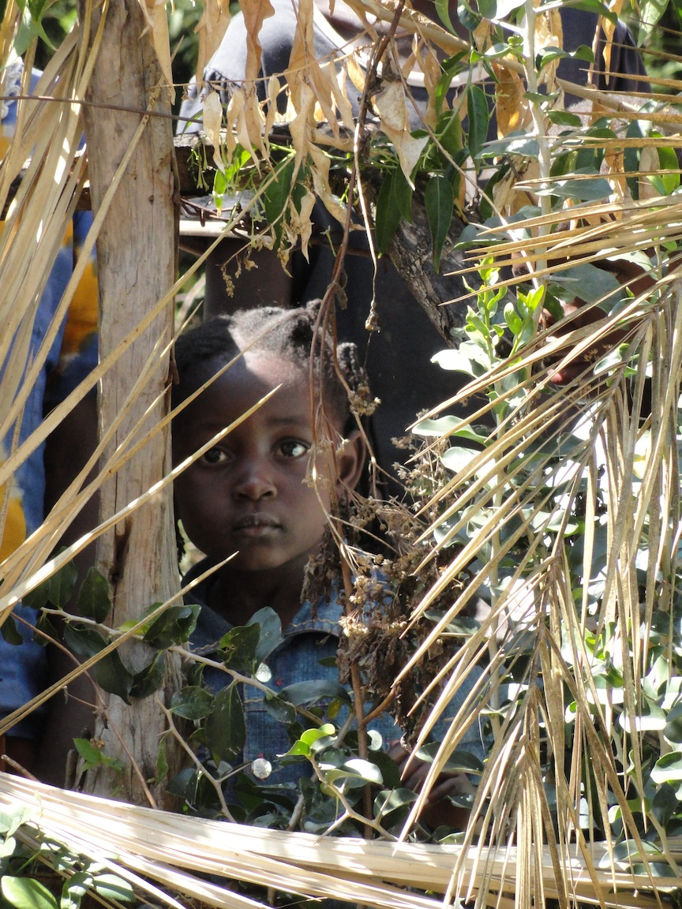
A beautiful people. A warm sun and bright smiles. A simple life. A touch that if firm and loving. A people strong and beautiful.
God is able.
God is Able. These simple and humble words I first noticed on truck windows and signs and later tastefully gracing the door jam of Macedonia Community Gardens and Educational Center. Never mind that Christmas was spelt incorrectly on the wall right nearby. The American southwestern motif decorating the rest of the newly re-plastered outhouse was hand detailed in simple black and white pin stripping. The outlining pattern that swept along the ground, up the corners, beneath the awnings, and straight into the words that seemed to grow from the building itself. God is Able. Unpretentious and humble.
Cement Sticks.
The lack of affordable building supplies has apparently led to the implementation of some rather handy solutions. With stucco or cob (adobe) seeming to be the preferred building design in these dry regions there is little that is needed outside of bricks, mortar, cement and clay. The real issue being the acquirement of something sturdy, light, and durable enough to use as forms for the laying of concrete walls. As with many countries around the world, the sign of continuing development and plan for growth in the future is the countless sticks of re-bar that protrude from the tops of many of the buildings. When one begins to build with reinforced concrete they must first build a form that is the negative of the intended structure. This is essentially the walls and ceilings, only supported from the posterior and reinforced with the iron re-bar that will make-up the skeletal structure for the concrete to adhere to. It’s sort of like building a building inside-out, pouring the concrete, and then taking the building back down. Only in Kenya the building is built out of branches. And when on the surface this may seem inferior on some level, it works well. The building comes down once poured. It simply needs to remain for a limited amount of time, normally until the second floor is ready to pour, at which time the entire process is preformed again. And Kenyans are very skilled in these processes as one can easily see from the well-built structures of all shapes and sizes. And, for sure this is the exact way people have been building for millennia. (Not the steel and concrete, but the implementation of locally available and accessible materials. Indeed the Asian world still uses bamboo scaffolding to great extent…many of tens of stories high.)
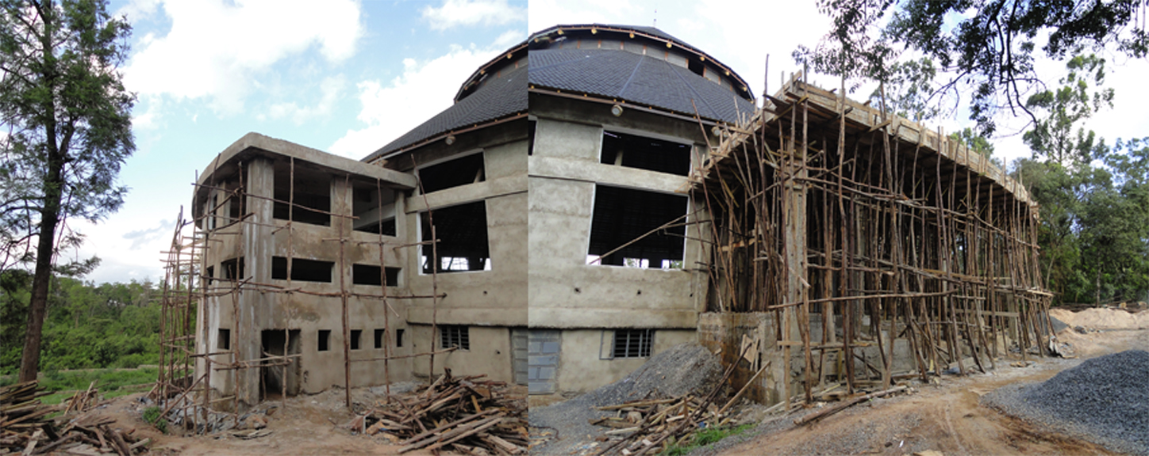
Pedal.Power.to.the.People.
I am a supreme lover of bicycles. The most efficient, enjoyable, economically friendly machine man has yet to invent. The Wright Brother were bicycle mechanics and they put us in flying machines! I live and breathe bicycles. I build my own from scratch and will work on anybodies damaged, worn, or neglected bicycle just to take joy in watching it role again. The bicycle shops in Kenya were often little more than a milk-crate or stump upon which a greasy-handed mechanic worked in the dirt with minimal tools. As we went past one of these shops, Whitney pointed out the fact that ‘Liam, that’s you if you were Kenyan.’ And I don’t think she could be closer to the truth. Building bicycles, keeping them rolling, and partaking in the joy people get from interaction from such simple, useful machines seems to be a calling of my life.
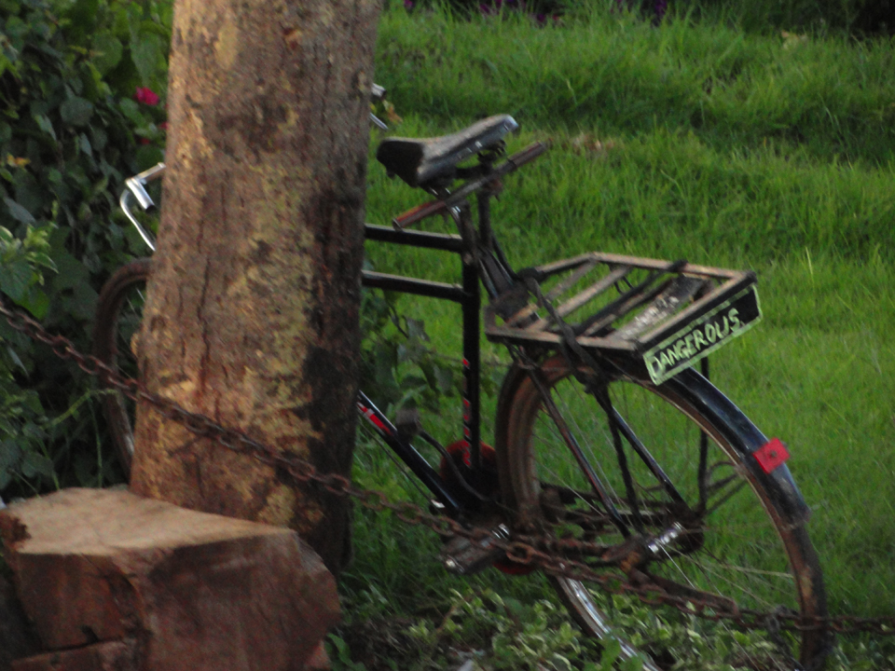
A Beautiful Rain that Falls.
Nearly every tour we were led upon began with the statement indicating that it was in fact now “the rainy season in Kenya”. Remembering that Emmondai had promised me, well in advance, that this truly WAS the case, I took this for granted. I assumed the first mornings showers to have been a fluke or late rain. Well, I was greatly impressed and, indeed, enlightened by the rains that we soon received upon the hot dry plains of Masai N.P. The stillness of the evenings. The Gradual abruptness with which the showers sprung upon us these nights was not only welcomed, but treasured, during the calm moments of relaxed disbelief. Whitney baptized herself standing among the raindrops as if she had no idea the boat was about to sink. That the sea was upon the rise.
Elephant Waste-Land. Park Ranger Bribe. And Flat Tire.
As we took a last early morning tour on our way through/out-of Masai Mara National Park we passed through a forest of leveled trees. Looking as if they were interrupted in their task of growing into strong members of this sparse forest upon the hill, they were the recently befallen by the brute strength of a local Elephant herd. Knocked down in displays of power and so as to make the vegetation of the upper regions available for eating, it was a rather sad devastation to have witnessed. A large bull worked one over as we passed, showing the brute force these magnificent animals are capable of and the lengths inhabitants of this sparse land must endure in-order to survive.
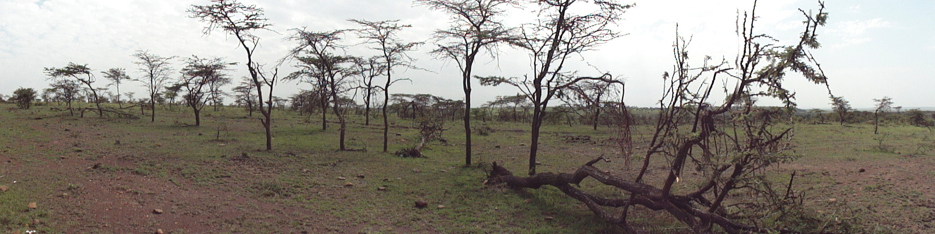
We skirted a few simply built Masai homes. They all seem to have but a window or two. I’m not sure what the reasoning behind this is. Either the need for structural strength or heat retention in the winter or cooling effects in the summer. A few acacia tree fences for the keeping of cattle and we were once again beyond the reaches of the Park. As we speed along down a road that one would surely expect to lead to the procurement of a flat tire Dr. Dave asked our driver Jeff how often he gets a flat tire. To which he shuns Dr. Wilson from having asked this question. Stating that this is a good way to jinx us. We speed along and are clocked perpendicularly by a nice, hunters green Toyota. Figuring they are just other tourists we don’t pay much mind. But as they race closer they split the gap between the roads we are both traveling upon and indicate for us to stop. The transaction was short and sweet. Jeff said that they informed him that we had traveled outside of the Parks bounds and upon restricted lands. Why this led to him handing the Park Rangers a stack of cash…I’m not sure. Probably something to do with us having not paid to get into the Park I the first place…but maybe not.
Getting passed by our cohorts, laughing and pointing as we were pulled off to the side of the road by ‘the man’, we were at the back of the three van caravan we had been traveling in for the last few days. So, when we get a flat tire, we are left to fend for ourselves on the side of the hot, dusty, dirt-road in what is basically the middle of the desert in Kenya. Good thing our boy Jeff was on his game. Four spare tires and e few good jokes about Dr. Dave having caused all the trouble we currently found ourselves in. The show was fast. (We spent most of in yucking-it-up with a few young locals. Though I’m sure nothing really got through to either one of the involved parties.)
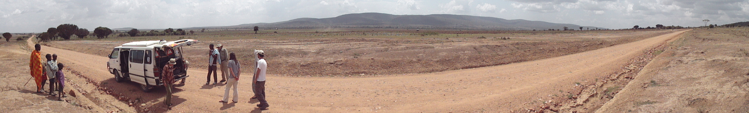
A sun that Refuses to Set.
On the flight back across the North Atlantic when the plane arches up over the Arctic in order to cut the apex of the transcontinental globe-slicing flight just-so, the sun didn’t set. I slowly set down upon the horizon, shone itself into through the back of my eyes and lit upon the cones within, sat there a bit longer, and then quietly and unceremoniously began it’s long, drawn-out arch back up the sky.
Reflection of the Soil whilst Upon a Plane : by Sarah Legg.
"If I could paint a picture, I would show all of the things that words cannot express. I would show the majestic animals of the African plains through the eyes of a young mazunga on a bouncing bus. I would paint Stephen, frolicking through a field and swinging his insect net, and Dan, hobbling along on his blistered feet. I would paint the Mara leisure camp in all of its splendor and elegance alongside the Masai warriors with their high jumps and tribal squeals. There would be a safari driver named Jeff, secretly paying the park rangers behind the bus, then later changing a flat tyre on a dusty road while dirty and impoverished children looked on with curiosity. I would paint Tuskers with deep browns and yellows, splashed with happiness and highlighted by good friends. There would be nearly sleepless nights in the jungle, crickets that sounded like wooden wind chimes, and skinny kale stalks with the leaves only on top. I would show rain in the desert and water in the wells, and I, the painter, would have a full tummy and a song in my heart. The painting would bleed, and its blood would run into the water, staining it with joy, longing, sadness, and suffering. The painting would be all: it would be me, it would be Africa."
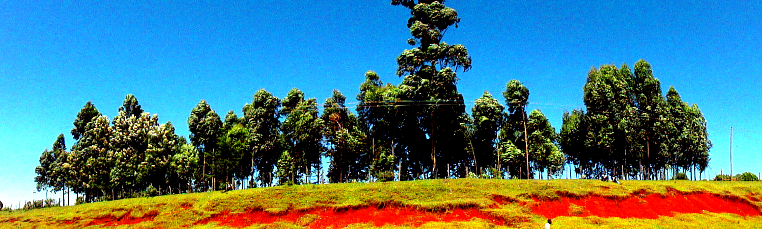
Pictures – Played in chronological order. So I ask that one can excuse the seeming random order of the following observation of one Liam Stockwell. Or mine…or me or my or thine, if you would. If I may.
These are the rest of the ideas I haven’t gotten to putting into the lay-out. I wish I had put more into the agricultural aspects of the paper but I’ve been getting carried away with the ideas of culture and peoples.
Compost and Compost tea and nutrient recycling
Double digging
Water conservation practices
Monoculture tea plantations
Indentured servitude and the possibility of promotions in life
Agroforestry
biofuels
Passport and hats for sale on street. Nuts! coat-rack!
3400 pound Glenfiddich. $5960 dollars. Staggering after just being in Nairobi and seeing how little it would take to go so far.
Property right? Ask Emmanuel Get price for Mara Leisure camp llc.
Nates job well done. The mosquito song in the morn.
The 14 yr. old at Macedonia and his mothers pride.
No ‘Yes” – sou sou - ok.ok.
Trash fires and need for sanitation department.
Go. Do.
Best coffee ever.
Hoe. Damn.
Wells - Highly needed.

